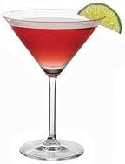

**Cosmopolitan**

**£7.50**

Vodka, Cointreau,

Cranberry Juice & Lime

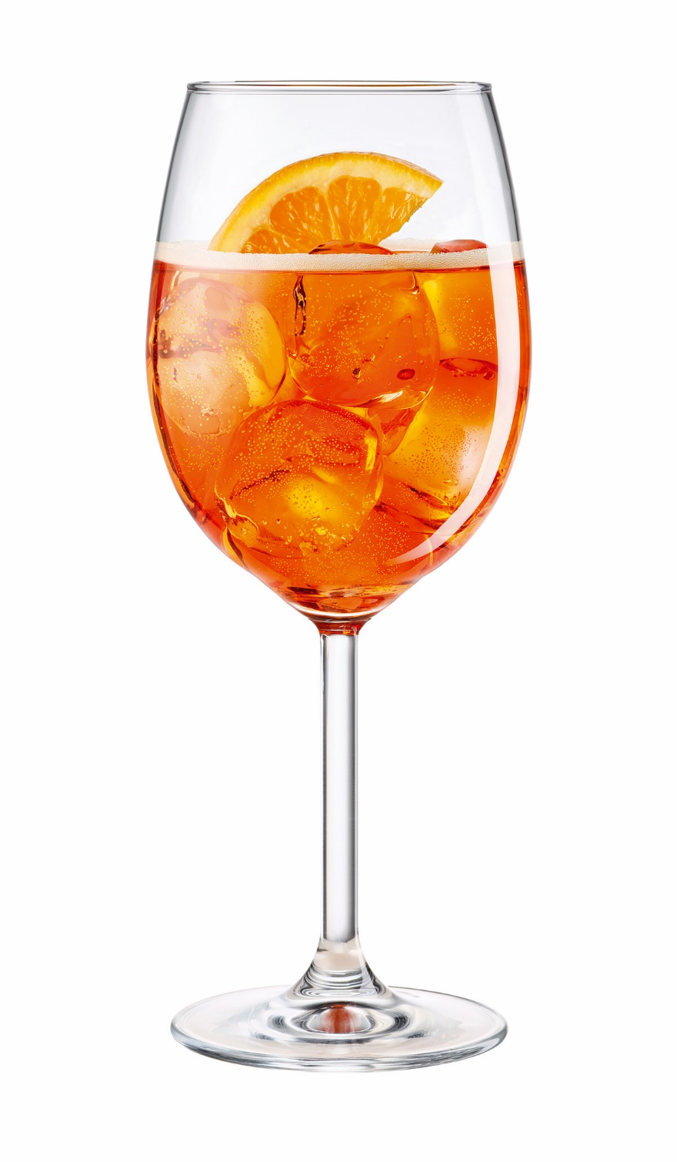

**Aperol Spritz**

**£7.50**

Aperol, Prosecco

& Soda Water

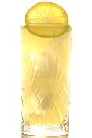

**Tom Collins**

**£7**

Gin, Lemon Juice,

Sugar Syrup & Soda Water

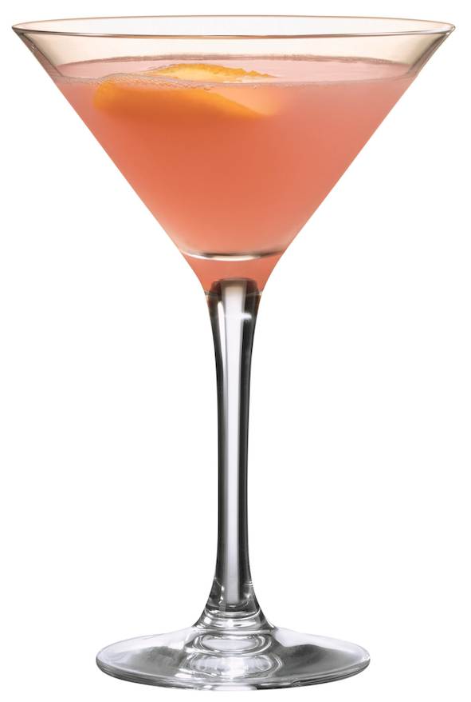

**Pornstar Martini**

**£7.50**

Vanilla Vodka, Passoa, lime juice, sugar syrup & a shot of prosecco

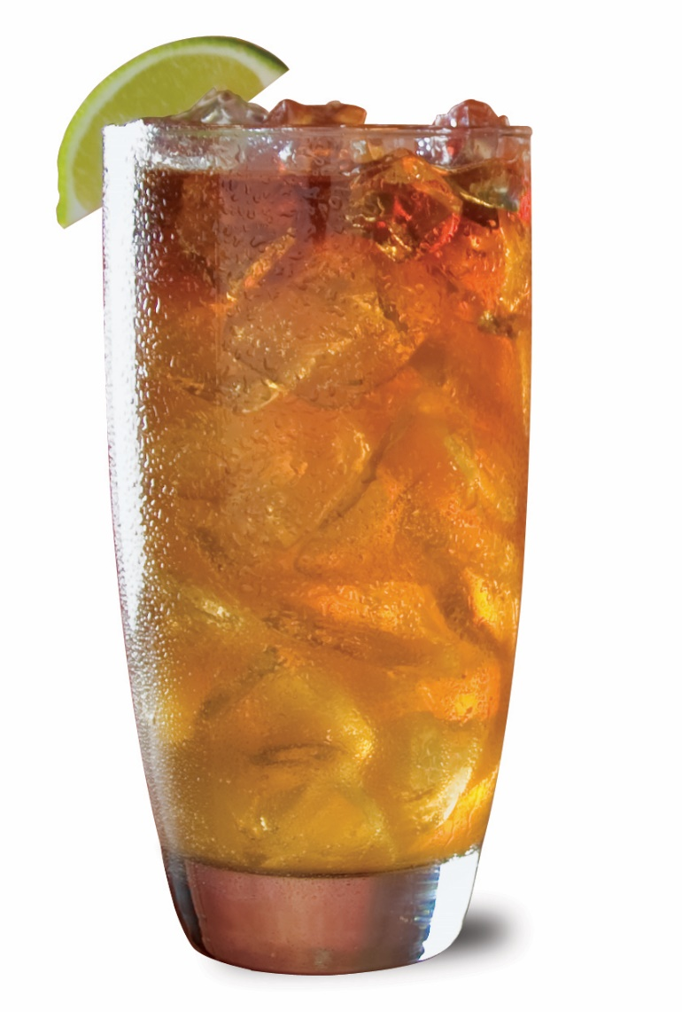

**Dark & Stormy**

**£7**

Dark Rum, Ginger Beer

& Lime Juice

\\\\\ **Cocktails** /////

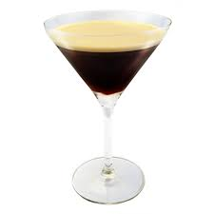

**Espresso Martini**

**£7.50**

Espresso Coffee, Vodka,

Tia Maria & Sugar Syrup

\\\\\ **Wine** /////

White / Rose / Red ~ 175ml / 250ml / Bottle

**White ~ Pinot Grigio £4.90 / £6.50 / £19 Sauvignon Blanc £4.50 / £6.20 / £18.50**

**Rose ~ Pinot Grigio Rose £4.90 / 6.50 / £19 Cabinet Sauvignon Rose £4.50 / £6.20 / £18.50**

**Red ~ Merlot £4.50 / £6.20 / £18.50 Rioja £4.90 / £6.50 / £19**

**Sparkling ~ Prosecco £6 / £25 Rose Prosecco £6 / £25**

**KOO**

\\\\\ **Spirits** /////

25ml / 50ml

**Jack Daniels**   **£3.50 / £6.50**

**Smirnoff Vodka**  **£3.50 / £6.50**

**Captain Morgan Dark Rum £3.50 / £6.50**

**Bacardi**  **£3.50 / £6.50**

\\\\\ **Mixers** /////

**Coca Cola / Diet Coke** **£2.50**

**Traditional Lemonade** **£2.70**

**Fiery Ginger Beer £3.00**

**Still** or **Sparkling Water** 250ml **£2.00**

**Orange** , **Apple** or **Cranberry Juice £2.50**

**Soda Water £2.00**

\\\\\ **Gins & Tonics** /////

25ml / 50ml

**Gordon’s Pink Gin**   **£3.50 / £6.50**

**Bombay Sapphire**  **£3.50 / £6.50**

**Hendricks £4 / £7**

**Whitley Neill Blood Orange Gin**  **£4 / £7**

**Warner’s Rhubarb Gin £4 / £7**

**Fevertree Tonic / Slimline Tonic** **£2.20**

\\\\\ **Beers, Ales & Ciders** /////

By bottle

**Peroni** 330ml  **£3**

**Corona** 330ml  **£4.50**

**Black Sheep Ale** 500ml **£3.50**

**Brampton Brewery Pale Ale** 500ml  **£3.50**

**Bulmers Original Cider** 500ml **£3**

**Kopparberg Mixed Fruit Cider** 500ml **£3.50**